MAST 382 Fall 2020
Exam 4

Instructions: The exam has two parts. Part I refers to questions related to Lectures 20 (Human Impacts) and 21 (Climate Change). Part II refers to Lectures 17 (Foundation of Life-Chapter 12), 18 (Marine Ecology-Chapter 14), 19 (Marine Ecosystems-Chapter 15) and external sources. Please note that the video that you are asked to watch in Part II Question 4 is about 1 hour long, budget your time accordingly.

Answer all questions. Upload the completed exam as a word document into Canvas saved as “Last name_exam 1”. We will not accept hand-written answers unless noted otherwise in the instructions to each question. The exam is due on 12/09/20 at 5 pm.

Part I: Questions related to Lectures 20 (Human Impacts) and 21 (Climate Change)

1. (5 pts) Please explain six ocean-related missions that fall under EPA's mandate to enforce the Clean Water Act of 1972 and its amendments in 1977 and 1987

2. (5 pts) State your home state or the state you were born. For this specific state, investigate the following using data from an U.S. Environmental Protection Agency (EPA) website that we used and accessed in class:

2.1 How many pounds (lbs.) of pollutants are managed/regulated by the EPA that are released (a) into the water and (b) into the air. Which chemical contributes the most in each category?

2.2 If you distribute the managed pollutant load equally over the entire population of your state, what is the per person contribution in your state (lbs. per person)?

2.3 Under what legal authority does the EPA collect and distributes these data?

3. (5 pts) If we assume that the apparent linear trend of decreasing US emissions of CO₂ per capita per year between 2008 and 2017 continues, how many years into the future will it take for us in the US to reach the per capita emissions of the European Union at 7 ton CO₂ per capita per year in 2017? [Hint: Muntean et al., 2018: Fossil CO2 emissions of all world countries - 2018 Report, European Union, doi:10.2760/30158 and graphs therein that we discussed in-class.]

4. (5 pts) A Newark, DE "University Farm" meteorological station is included in global data bases to estimate global and regional climate change. What is the warming (in degrees Celsius per century) for this station and how does it compare to regional, national, and global expectations? Note that the records at

http://berkeleyearth.org/data-new

[Hint: You may want to search for "Individual Station Data" rather than gridded averages.]

5. (5 pts) Please read the Op-Ed "The conversion of a Climate Change Skeptic," at
https://www.nytimes.com/2012/07/30/opinion/the-conversion-of-a-climate-change-skeptic.html
that appeared in the New York Times in 2012. Try to answer the following questions

5.1 What did Prof. Mueller do to change his mind about climate change?

5.2 What errors are contained within air temperature data used to estimate a global average?

5.3 How does his conclusion differ from that of the International Panel of Climate Change?

5.4 How important are effects due to solar cycles, volcanos, and ocean currents on climate change?

5.5 Can Hurricane Katrina and the 1800 people killed by it in New Orleans be attributed to a changing climate? If so why? If not, why not?

6. (5 pts) Modern Climate Change models use both assumed CO₂ emission scenarios and assumed policy scenarios to project our current climate 50-100 years into the future. In your opinion, which of the five "Shared Socioeconomic Pathways" (SSP listed in Table-2 of Riahi et al. (2017) and reproduced below) should be used for the United States of America for the next 50-100 years? Putting this question in another way, I ask you as scientists and citizens which of these five scenarios describe our nations's likely attitudes, outlooks, and behaviors best for the next 50 years or so? Please explain both your reasoning and elaborate by reflecting on your own and your larger community's perspectives.

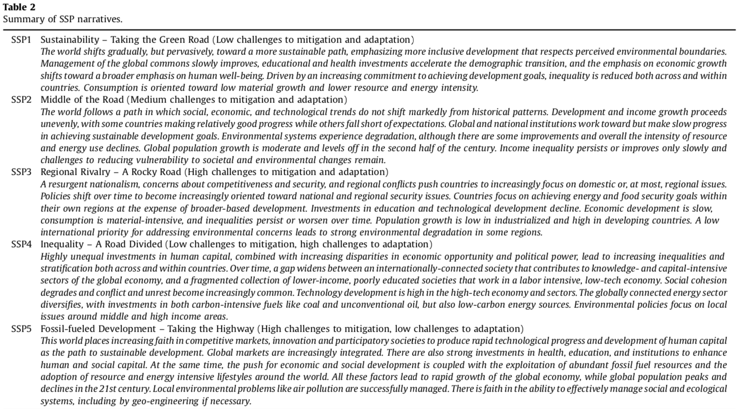

[The original peer-reviewed paper is posted on Canvas in the same directory as all class materials from Nov.-30, e.g., Files>MuenchowLectures>Lecture21_Climate>2017-Riahi.pdf.]

Part II Questions from Chapters 12, 14, and 15 and external sources.

Question 1 (10 points): The following is a list of “vocabulary” the mastery of which is important in learning the language of marine life and ecology. Provide a short explanation, or definition, that demonstrates that you have understood the concept in the context of this course. Do not copy definitions from Wikipedia, these will not earn you any credit (I will check).

a-primary production

b-food chain

c-trophic level

d-countershading

e-epifauna

f-symbiosis

g-osmoregulation

h-fundamental niche

i-supralittoral zone

j-tube worms

Question 2: About iron fertilization (30 points) Read the article “Will Ocean Iron Fertilization Work?” posted in the Exam 4 folder on Canvas. Answer the following three questions. Make sure to pay attention to the specific word counts. List the number of words at the end of your paragraph.
a-While adding iron to the ocean seems simple, why is it so difficult to conduct iron fertilization experiments (100-150 words, 10 points)?
b-According to the article, what is meant with “location, location, location”? What is the best location and why (100-150 words, 10 points)?
c-Discuss whether or not, or to what extent, Fe fertilization works (100-150 words, 10 points).

Question 3 (10 points): “Build-a-Fish”:

a) (5 points) Describe a fish that is adapted to life in a coral reef. Your description will include the general body shape of the fish (1 point), at least two types of fins (2 points), and two adaptions of your choosing that help it succeed in what it does (2 points). For full credit, your description must include a justification, or explanation, of the purpose of the particular shape, fins, and adaptations.

b) Sketch your fish and label all adaptations that you describe above. (Take a picture of your sketch and insert as a jpg) (5 points).

Question 4 (20 points). Watch the lecture “The Biggest Control Knob” by Richard Allen available via the link below and answer the following questions (note that the lecture is about 60 minutes long):
https://www.youtube.com/watch?v=3UVb--2-PBg

a) According to Alley, what is the biggest control knob (1 point)? A single word answer will suffice.

b) Pick one of the warm intervals in the geologic past that Alley describes and provide a brief summary (3-5 sentences, no more than 50-80 words) (5 points). For full credit, tell me which warm interval you picked (1 point), the approximate age of the event (1 point), and what appears to have happened (3 points).

b) What is Alley’s analogy for CO₂ being important in climate (1 point) and explain how it works (8 point)?

c) What question do you have for the speaker (5 points)? This question has to relate to his lecture. For full credit, the question has to be properly formulated. This means that your question has to refer to a specific part of the lecture. For example, you might ask “In your lecture you mentioned that xxx does yyy…, now I am wondering why/how/….” Or: “In your lecture you talked about xxx, zzz, and yyy, what do you think about why vvvv….?”

